When **"Get All Employees"** button is clicked we want to retrieve all the employees and display their fullname in unordered list. When **"Clear"** button is clicked we want to clear the employees from the list.   
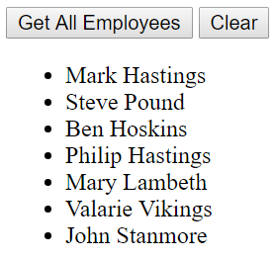 

<!DOCTYPE html>

<html>

<head>

    <title></title>

    <meta charset="utf-8" />

    <script src="Scripts/jquery-1.10.2.js"></script>

    <script type="text/javascript">

        $(document).ready(function () {

            var ulEmployees = $('#ulEmployees');

            $('#btn').click(function () {

                $.ajax({

                    type: 'GET',

                    url: "api/employees/",

                    dataType: 'json',

                    success: function (data) {

                        ulEmployees.empty();

                        $.each(data, function (index, val) {

                            var fullName = val.FirstName + ' ' + val.LastName;

                            ulEmployees.append('<li>' + fullName + '</li>');

                        });

                    }

                });

            });

            $('#btnClear').click(function () {

                ulEmployees.empty();

            });

        });

    </script>

</head>

<body>

    <div>

        <input id="btn" type="button" value="Get All Employees" />

        <input id="btnClear" type="button" value="Clear" />

        <ul id="ulEmployees" />

    </div>

</body>

</html>

In our case both the client (i.e the HTML page that contains the ajax code) and the asp.net web api service are in the same project so it worked without any problem. If they are present in different projects then this wouldn't work.